Experiment Title
Text Processing using Tokenization and Stop Word Removal

Aim
To implement basic text processing techniques such as Tokenization and Stop Word Removal using Python and NLTK.

Introduction
Natural Language Processing (NLP) is a branch of Artificial Intelligence that enables computers to understand, analyze, and process human language. Raw text data cannot be directly processed by a machine. Therefore, text must be preprocessed before applying any NLP task.
Tokenization and Stop Word Removal are the initial and most important steps in the NLP pipeline. These steps convert raw text into a structured form suitable for further analysis.

NLP Pipeline
The general NLP pipeline consists of the following steps:
- Text Input
- Tokenization
- Stop Word Removal
- Stemming / Lemmatization
- Feature Extraction
- NLP Task (Classification, Translation, etc.)
In this experiment, Tokenization and Stop Word Removal are implemented.

Tokenization
Tokenization is the process of breaking a given text into smaller units called tokens. Tokens can be words, punctuation marks, or symbols.
- import nltk
nltk.download('punkt')
nltk.download('punkt_tab')

from nltk.tokenize import word_tokenize

text = "Natural Language Processing is an interesting subject."

tokens = word_tokenize(text)
print("Tokens:", tokens)
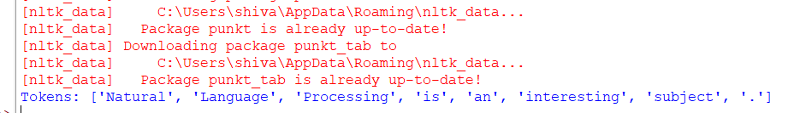
b) import nltk
nltk.download('punkt')
nltk.download('punkt_tab')
nltk.download('stopwords')

from nltk.tokenize import word_tokenize
from nltk.corpus import stopwords

text = "Natural Language Processing is an interesting subject"

tokens = word_tokenize(text)
stop_words = set(stopwords.words('english'))

filtered_words = [word for word in tokens if word.lower() not in stop_words]

print("After Stop Word Removal:", filtered_words)
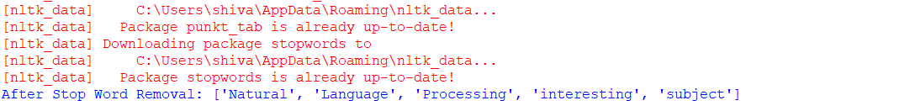
2)
import nltk
nltk.download('punkt')

from nltk.tokenize import word_tokenize
from nltk.stem import PorterStemmer

# Create Porter Stemmer object
ps = PorterStemmer()

# Input text
text = "Natural Language Processing involves processing words and reducing words to their root form"

# Tokenize the text
tokens = word_tokenize(text)

print("Original Words:")
print(tokens)

print("\nStemmed Words:")
for word in tokens:
print(word, "->", ps.stem(word))
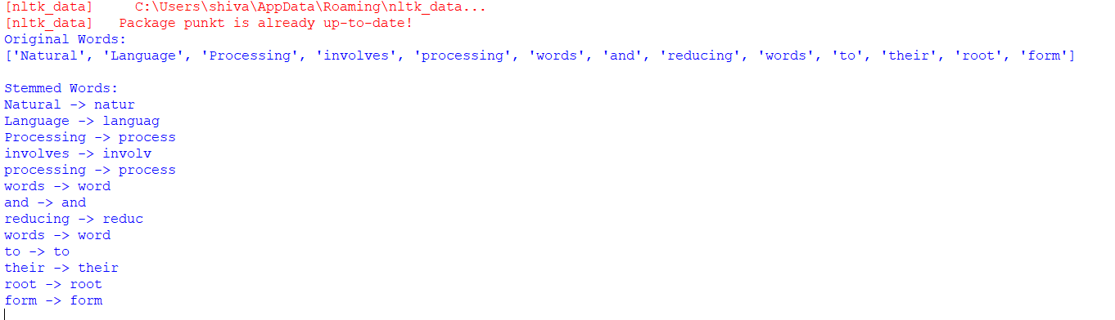

Experiment Title
Implementation of Porter Stemmer Algorithm

Aim
To implement the Porter Stemming Algorithm using Python and NLTK to reduce words to their root form.

Introduction
. In Natural Language Processing (NLP), words often appear in different forms such as connect, connected, connecting. Processing all these forms separately increases complexity. To handle this problem, stemming is used.
Stemming is the process of reducing words to their base or root form by removing suffixes. The Porter Stemmer is one of the most widely used stemming algorithms in NLP.

Stemming
Stemming removes common suffixes such as –ing, –ed, –ly, –s from words. The resulting word is called a stem. The stem may not always be a valid dictionary word.

Example:
Original Word | Stem
processing | process
connected | connect
running | run

Porter Stemmer Algorithm
The Porter Stemmer is a rule-based algorithm proposed by Martin Porter in 1980. It applies a sequence of rules in multiple steps to remove suffixes from words.
The algorithm works in five main steps, where each step applies a set of rules to reduce the word to its stem. These rules are based on:
- Word length
- Presence of vowels
- Common English suffix patterns

Steps of Porter Stemmer
- Removal of plural suffixes (–s, –es)
- Removal of past tense suffixes (–ed)
- Removal of continuous tense suffixes (–ing)
- Removal of derivational suffixes (–ation, –izer, –fulness)
- Final normalization of the stem

NLTK and Porter Stemmer
NLTK (Natural Language Toolkit) provides a built-in implementation of the Porter Stemmer. It simplifies the process of stemming and avoids writing complex rules manually.
The PorterStemmer() class in NLTK is used to perform stemming operations on words

Algorithm

Algorithm for Porter Stemmer
- Import required NLTK modules
- Create a Porter Stemmer object
- Read input text
- Tokenize the text into words
- Apply Porter Stemmer to each word
- Display the stemmed words
3 ) Write Python Program for a) Word Analysis b) Word Generation
- Word analysis
import nltk
from nltk.tokenize import word_tokenize

# Download tokenizer (run only once)
nltk.download('punkt')

# Sample text
text = "Natural language processing (NLP) is the ability of a computer program to understand human language as it is spoken."

# Tokenize the text into words
tokens = word_tokenize(text)

# Print tokens
print("Tokens:")
print(tokens)

# Perform frequency analysis on the tokens
word_freq = nltk.FreqDist(tokens)

# Print the 10 most frequent words
print("\nThe 10 most frequent words are:")
for word, freq in word_freq.most_common(10):
print(f"{word}: {freq}")
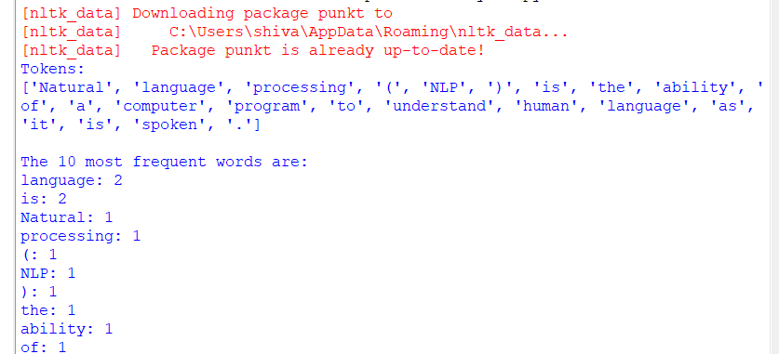

- word generation
# Word Generation using user input (no random values)

# Function to generate words
def generate_words(root_word):
suffixes = ['s', 'ing', 'ed', 'er', 'ness']
generated_words = []

for suffix in suffixes:
generated_words.append(root_word + suffix)

return generated_words

# Take input from user at runtime
root = input("Enter a root word: ")

# Generate words
result = generate_words(root)

# Print generated words
print("\nGenerated Words:")
for word in result:
print(word)
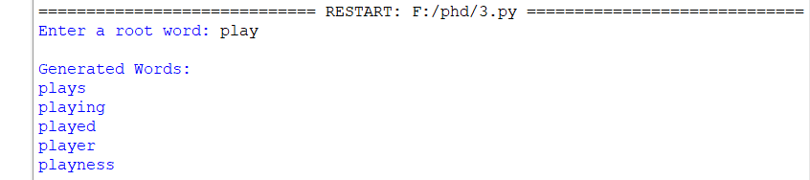

Experiment Title
Word Sense Disambiguation

Aim
To implement Word Sense Disambiguation (WSD) using Python and NLTK in order to identify the correct meaning of ambiguous words based on context.

Introduction
In Natural Language Processing, many words have more than one meaning. Such words are called ambiguous words. Humans easily understand the correct meaning of a word by observing the context, but it is difficult for a computer to do the same.
Word Sense Disambiguation (WSD) is the task of determining the correct meaning (sense) of a word when it appears in different contexts. WSD plays an important role in applications such as machine translation, information retrieval, and question answering systems.

Ambiguous Words
An ambiguous word is a word that has multiple meanings.

Examples:
Word | Meanings
bank | financial institution / river side
bat | animal / sports equipment
plant | factory / living organism
crane | bird / machine
mouse | animal / computer device

Word Sense Disambiguation (WSD)
Word Sense Disambiguation is the process of assigning the correct meaning to an ambiguous word based on the surrounding words in a sentence.

Example:
- I deposited money in the bank → bank = financial institution
- The children sat on the river bank → bank = river side

Lesk Algorithm
The Lesk Algorithm is a classical and dictionary-based approach to WSD. It works by comparing the words in the given sentence with the dictionary definitions of each possible meaning of the ambiguous word.
The sense whose definition has the maximum overlap with the context words is selected as the correct sense.

WordNet
WordNet is a large lexical database of English provided by NLTK. It groups words into sets of synonyms called synsets and provides:
- Definitions
- Examples
- Relationships between words
The Lesk algorithm uses WordNet to obtain possible meanings of ambiguous words.

Algorithm

Algorithm for Word Sense Disambiguation
- Import required NLTK libraries
- Read the input sentence containing an ambiguous word
- Tokenize the sentence into words
- Apply the Lesk algorithm
- Compare context words with WordNet definitions
- Select the sense with maximum overlap
- Display the correct sense and its definition

Working Principle
- The sentence is tokenized into words
- The ambiguous word is identified
- All possible meanings of the word are obtained from WordNet
- Each meaning is compared with the context
- The most relevant meaning is selected

Applications of WSD
- Machine Translation
- Information Retrieval
- Question Answering Systems
- Text Summarization
- Chatbots
- # Word Sense Disambiguation using Lesk Algorithm

Program:

import nltk
from nltk.wsd import lesk
from nltk.tokenize import word_tokenize

nltk.download('punkt')
nltk.download('wordnet')

sentence = input("Enter a sentence: ")
ambiguous_word = input("Enter the ambiguous word: ")

tokens = word_tokenize(sentence)

sense = lesk(tokens, ambiguous_word)

print("\nWord Sense Disambiguation Result:")
print("Sentence:", sentence)
print("Ambiguous Word:", ambiguous_word)

if sense:
print("Identified Sense:", sense.definition())
else:
print("Sense could not be identified")
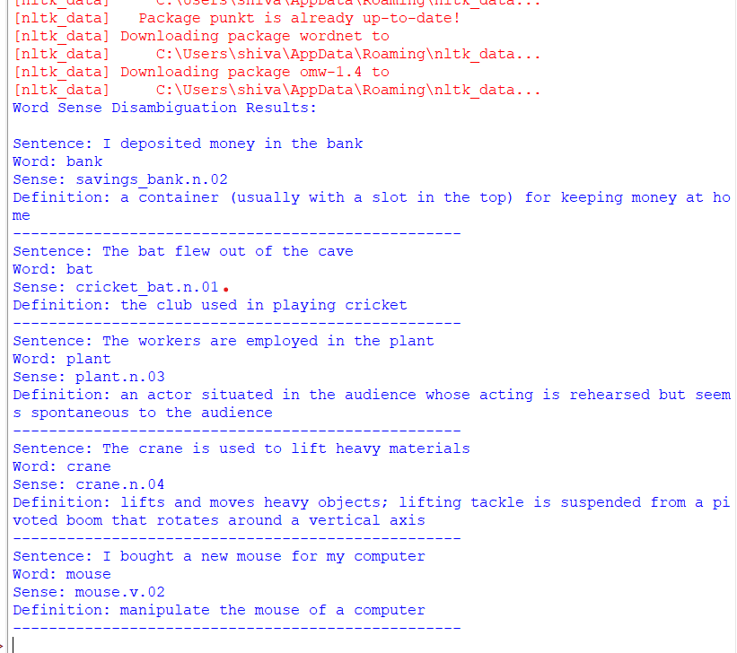

NLP Lab: Install NLTK Toolkit and Perform Stemming

1. Aim
To install the Natural Language Toolkit (NLTK) in Python and perform stemming on words using different stemmers.

2. Theory
Natural Language Toolkit (NLTK) is a popular Python library used for Natural Language Processing (NLP) tasks such as tokenization, stemming, tagging, parsing, and classification.
Stemming is the process of reducing words to their root or base form by removing suffixes.
Example:
Word | Stem
playing | play
played | play
playing | play
happiness | happi
Common stemmers in NLTK:
- Porter Stemmer
- Lancaster Stemmer
- Snowball Stemmer

3. Installation of NLTK

Step 1: Install NLTK
Open Terminal / Command Prompt and run:
pip install nltk

Step 2: Download Required NLTK Data
import nltk
nltk.download('punkt')

4. Program: Stemming using NLTK
import nltk
from nltk.stem import PorterStemmer
from nltk.stem import LancasterStemmer
from nltk.stem import SnowballStemmer
# Sample words
words = ["playing", "played", "happiness", "running", "studies"]
# Porter Stemmer
ps = PorterStemmer()
print("Porter Stemmer Output:")
for w in words:
print(w, "->", ps.stem(w))
# Lancaster Stemmer
ls = LancasterStemmer()
print("\nLancaster Stemmer Output:")
for w in words:
print(w, "->", ls.stem(w))
# Snowball Stemmer
ss = SnowballStemmer("english")
print("\nSnowball Stemmer Output:")
for w in words:
print(w, "->", ss.stem(w))

5. Sample Output
Porter Stemmer Output:
playing -> play
played -> play
happiness -> happi
running -> run
studies -> studi
Lancaster Stemmer Output:
playing -> play
played -> play
happiness -> happy
running -> run
studies -> study
Snowball Stemmer Output:
playing -> play
played -> play
happiness -> happi
running -> run
studies -> studi

NLP Lab: POS Tagging Using NLTK

1. Aim
To create a sample list of words and perform Part-of-Speech (POS) tagging to identify the grammatical category of each word.

2. Theory
Natural Language Toolkit provides tools for many NLP tasks including POS tagging.
Part-of-Speech Tagging is the process of assigning a grammatical category to each word in a sentence.
Examples of POS tags:
Tag | Meaning | Example
NN | Noun | dog, book
VB | Verb | run, write
JJ | Adjective | beautiful
RB | Adverb | quickly
DT | Determiner | the, a

3. Installation
Install NLTK:
pip install nltk
Download required datasets:
import nltk
nltk.download('punkt')
nltk.download('averaged_perceptron_tagger')

4. Program: POS Tagging
import nltk
from nltk import pos_tag
from nltk.tokenize import word_tokenize
# Sample list of words (10 words)
words = ["computer", "runs", "beautiful", "quickly", "teacher",
"write", "happy", "students", "study", "smart"]
# POS tagging
tagged_words = pos_tag(words)
print("POS Tags for the sample list:")
for word, tag in tagged_words:
print(word, ":", tag)
# Find POS for a given word
given_word = input("\nEnter a word to find its POS: ")
result = pos_tag([given_word])
print("POS Tag:", result[0][1])

5. Sample Output
POS Tags for the sample list:
computer : NN
runs : VBZ
beautiful : JJ
quickly : RB
teacher : NN
write : VB
happy : JJ
students : NNS
study : VB
smart : JJ
Enter a word to find its POS: playing
POS Tag: VBG

- (a) Morphological Analysis
- (b) Generate N-grams
- (c) Implement N-gram Smoothing

NLP Lab Program

Aim
Write a Python program to:
- Perform Morphological Analysis
- Generate N-grams
- Implement N-gram Smoothing

Step 1: Install Required Library
pip install nltk
Download datasets:
import nltk
nltk.download('punkt')

(a) Morphological Analysis using NLTK
Morphological analysis studies word structure (prefix, suffix, root word).
Example:
playing → play + ing

Program
import nltk
from nltk.stem import PorterStemmer
from nltk.tokenize import word_tokenize
text = "players were playing happily in the playground"
# Tokenization
words = word_tokenize(text)
# Morphological Analysis using stemming
stemmer = PorterStemmer()
print("Morphological Analysis (Stemming):")
for word in words:
print(word, "->", stemmer.stem(word))

Sample Output
players -> player
were -> were
playing -> play
happily -> happili
playground -> playground

(b) Generate N-grams using NLTK
N-grams are sequences of N words.
Examples:
Type | Example
Unigram | NLP
Bigram | Natural Language
Trigram | Natural Language Processing

Program
import nltk
from nltk.util import ngrams
from nltk.tokenize import word_tokenize
text = "Natural language processing is interesting"
tokens = word_tokenize(text)
# Generate Bigrams
bigrams = list(ngrams(tokens, 2))
# Generate Trigrams
trigrams = list(ngrams(tokens, 3))
print("Bigrams:")
print(bigrams)
print("\nTrigrams:")
print(trigrams)

Output
Bigrams:
[('Natural','language'), ('language','processing'),
('processing','is'), ('is','interesting')]
Trigrams:
[('Natural','language','processing'),
('language','processing','is'),
('processing','is','interesting')]

(c) Implement N-Gram Smoothing
Smoothing avoids zero probability for unseen words.
Example method: Laplace Smoothing

Program
from collections import Counter
from nltk.util import bigrams
from nltk.tokenize import word_tokenize
text = "I love natural language processing and I love machine learning"
tokens = word_tokenize(text)
# Create bigrams
bi = list(bigrams(tokens))
# Count frequencies
unigram_counts = Counter(tokens)
bigram_counts = Counter(bi)
V = len(unigram_counts)
print("Bigram Probabilities with Laplace Smoothing:\n")
for w1, w2 in bi:
probability = (bigram_counts[(w1, w2)] + 1) / (unigram_counts[w1] + V)
print(f"P({w2}|{w1}) = {probability:.3f}")

- Convert Audio → Text (Speech Recognition)
- Convert Text → Audio (Text to Speech)
Note: NLTK itself does not directly convert audio to text. For speech processing we commonly use SpeechRecognition and pyttsx3 along with Python.

NLP Lab Program: Audio to Text and Text to Audio

Aim
To convert:
- Audio file to text
- Text file to audio

Step 1: Install Required Libraries
Open Command Prompt / Terminal
pip install nltk
pip install SpeechRecognition
pip install pyttsx3
pip install pyaudio

(a) Convert Audio File to Text

Program
import speech_recognition as sr
# Initialize recognizer
r = sr.Recognizer()
# Load audio file
with sr.AudioFile("sample.wav") as source:
audio = r.record(source)
# Convert speech to text
try:
text = r.recognize_google(audio)
print("Converted Text:")
print(text)
except:
print("Error in recognizing speech")

Sample Output
Converted Text:
Natural language processing is very interesting

(b) Convert Text File to Audio

Program
import pyttsx3
engine = pyttsx3.init()
# Read text file
file = open("text.txt","r")
text = file.read()
# Convert text to speech
engine.say(text)
engine.runAndWait()
If text.txt contains:
Natural Language Processing lab experiment
The system will read the text aloud.

